This document is a(n) …..
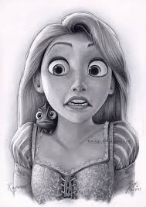  drawing | 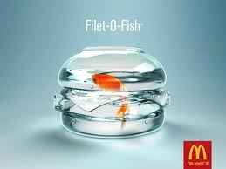  advertisement | 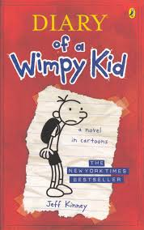  cover | 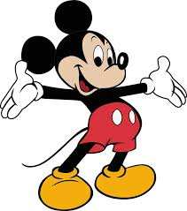  cartoon | 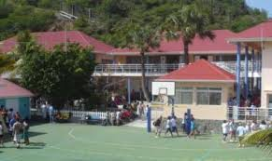  photograph | 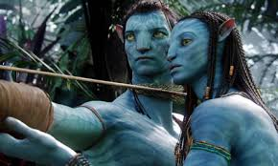  film still
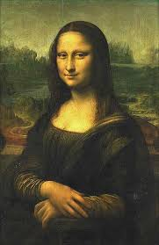  painting | 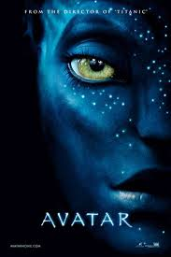  poster | 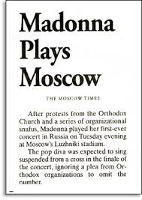  article | 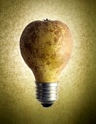  photomontage | 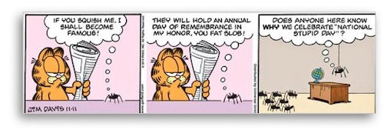  (comic) strip
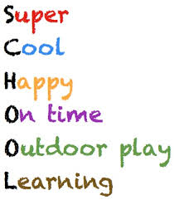  poem | letter | 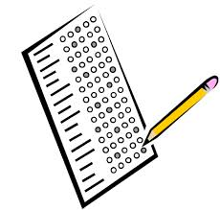  survey | 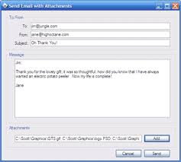  email
1. Identifie sa nature. Mentionne l’auteur, la date et l’origine si possible.

It (probably) comes from a …
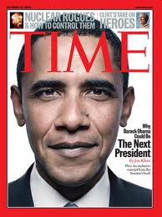  magazine | 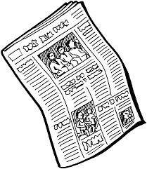  newspaper | novel | 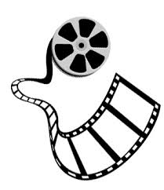  film / play | 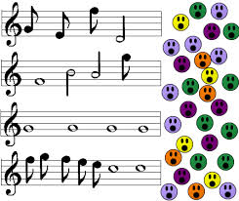  song | 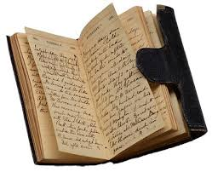  diary / journal
It was drawn / created / written by (…)  It was painted / taken by (…)  It was shot / published by (…) | It first appeared in ( + date )  It is recent / old  It dates from…

2. Décris ce que tu vois en tentant de répondre aux questions suivantes :
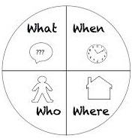

Parle du décor et des personnages. Qui et qu’y a-t-il? Où?

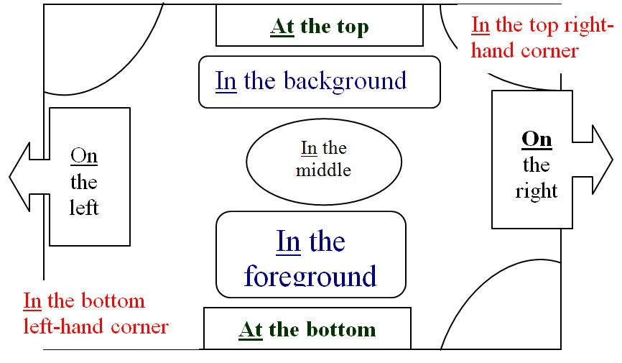

Useful expressions
The scene takes place in … / at… It is composed of… / There is / are…  The main character(s) is / are … |  | Our attention is caught / drawn by …  We are struck by … / It shows …  We can see / notice (that )…

Suppositions and probability | Opinion
Maybe / Perhaps …  It must / may / might be …  They are probably … / This is certainly … | It seems to me that … / To my mind, …  I believe (that) … / In my opinion, …  I think (that) … / From my point of view …
Interpretations
It represents / illustrates …  It expresses …  It pictures / depicts …  It embodies / symbolizes … | The author wants to …  The message is … / The purpose is to …  It’s a criticism of …  In conclusion / To conclude …
3. Fais part de ton interprétation personnelle du document et donne ton opinion.

